**SEQUENTIAL DIAGRAM**

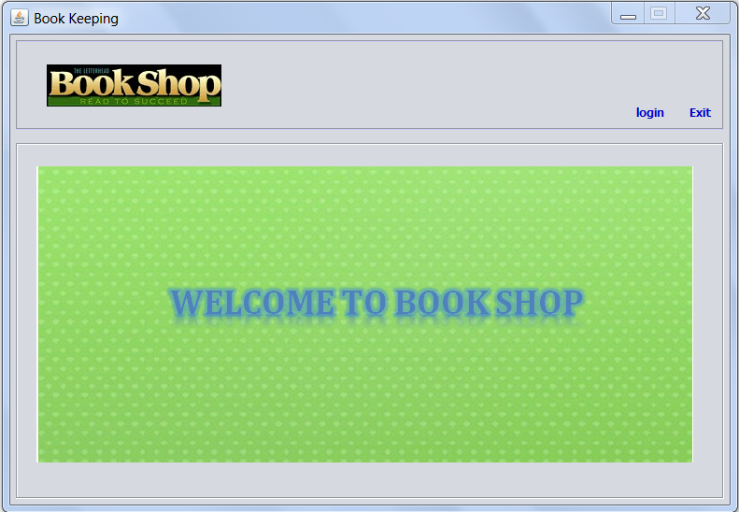

Main Page Interface

In above Interface, two buttons are included: **LOGIN** and **EXIT**.

On pressing **LOGIN** button, **LOGIN** window will be appeared:

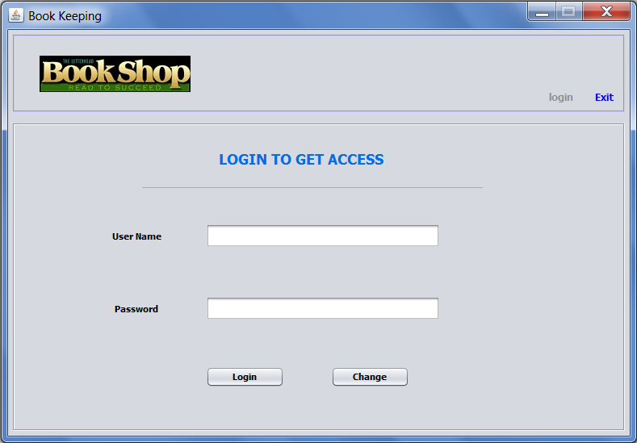

LOGIN Window

And on pressing **EXIT** button in **Main Page** Window, a Pop-Up of ‘really want to exit’ appears:

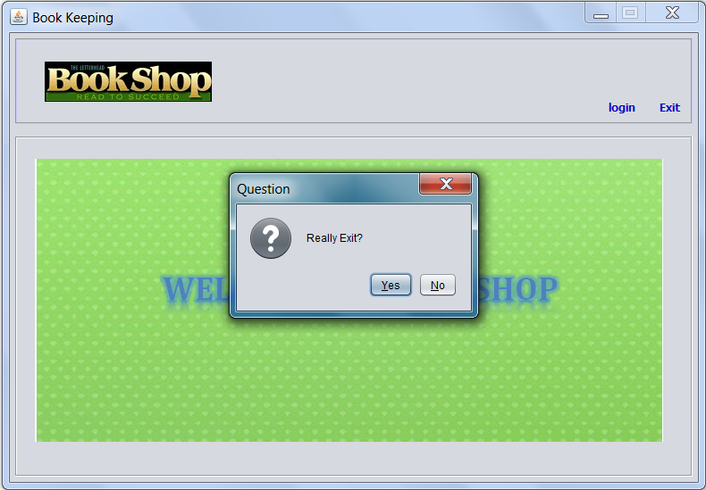

Exit Pop-Up